Assignment 1

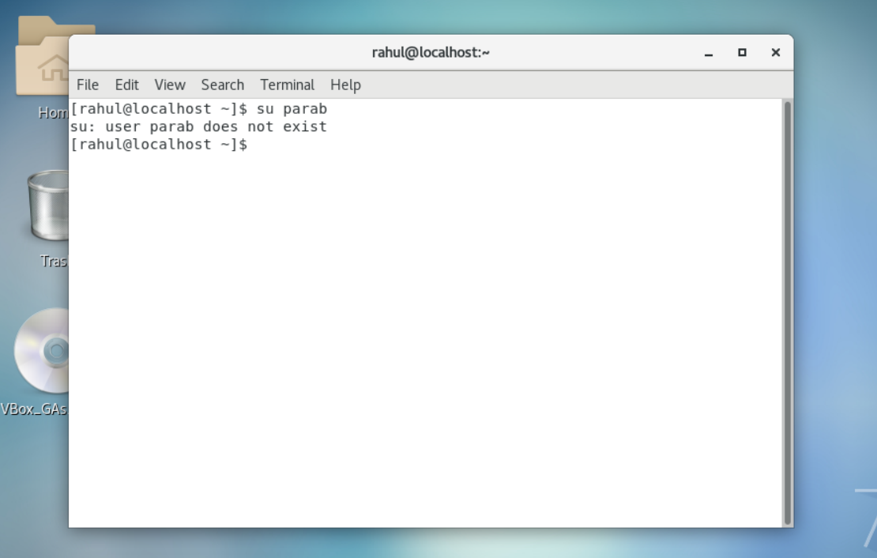

We can see that if we try to login a non existent user, the terminal will throw us a prompt that: The User doesn’t exist

Assignment 2

1.

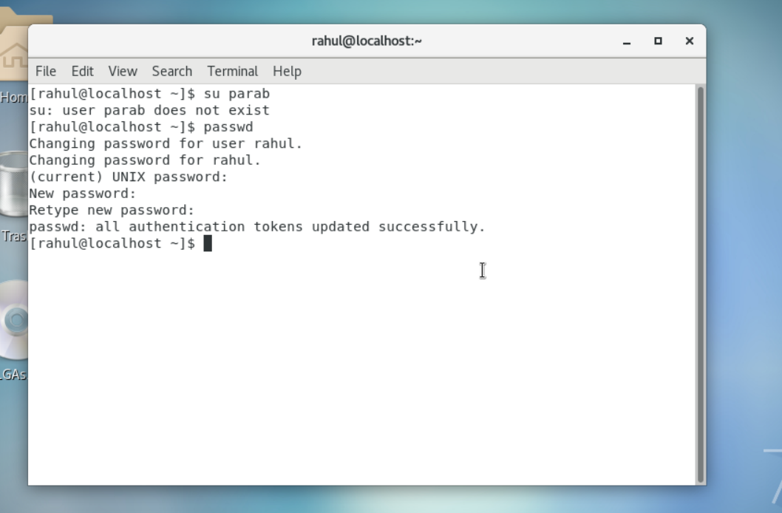

Here I have changed the password to iNeuron#42.

1. To change the password, I used the command: passwd
2. First it asked me my current password (Note: U can’t see the password while typing)
3. Then I typed the new Password iNeuron#42
4. After successful password update , terminal prompts the following line : all authentication Tokens updated successfully

* Updated the password to 1234

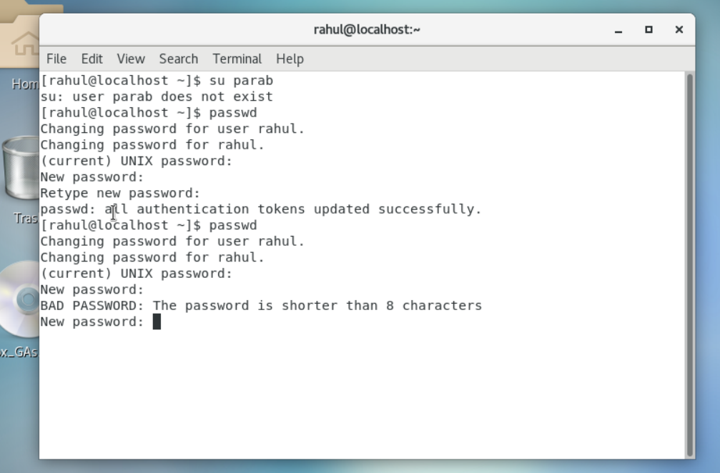

1. To change the password, I used the command: passwd
2. First it asked me my current password (Note: U can’t see the password while typing)
3. Then I typed the new Password 1234 which is a bad password as it is shorter than 8 characters and therefore we can use this as a password.

*  I don’t use any password just hit **Enter** key

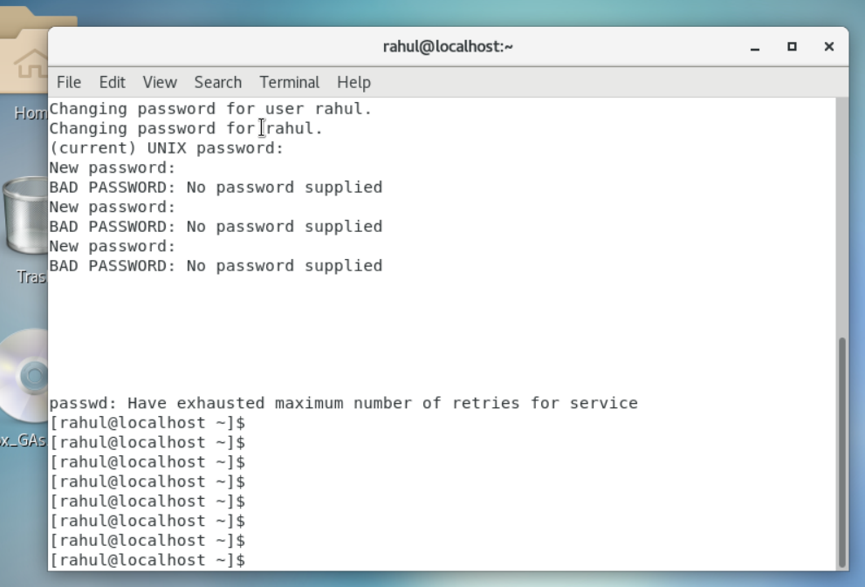

1. To change the password, I used the command: passwd
2. First it asked me my current password (Note: U can’t see the password while typing)
3. Without entering any new password I just hit Enter , to which the terminal throws the following prompt: Bad Password -> No password Supplied
4. After hitting Enter without inputting a password for multiple times I get the following as shown in the above screenshot.

Assignment 3

* Enter the command **cd /** and then **ls** and then hit **Enter** key

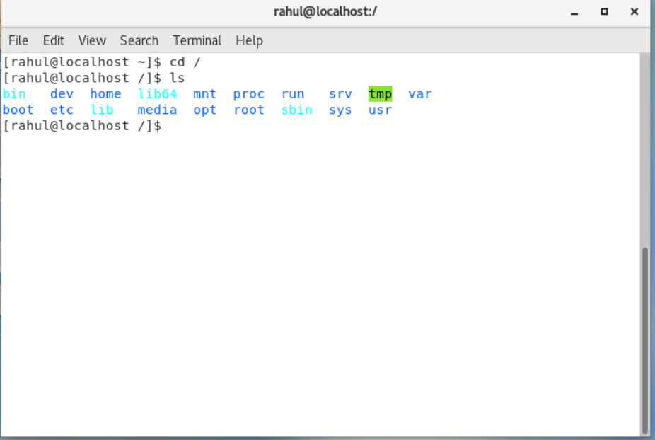

The command ‘cd / ‘ changes directory to the root directory which is is the first directory in your filesystem hierarchy and ls list lists out all the directories present there

* Enter the command now **cd /home** and then hit **Enter** key

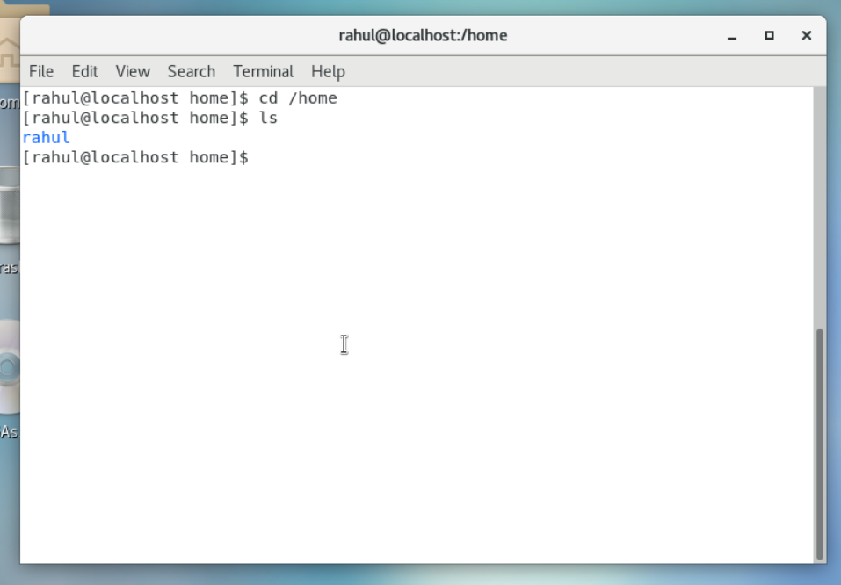

Cd /home : The home directory can be said as a personal working space for all the users except root. There is a separate directory for every user. It is directory for a particular user of the system and consists of individual files of the user.

* Cd ..

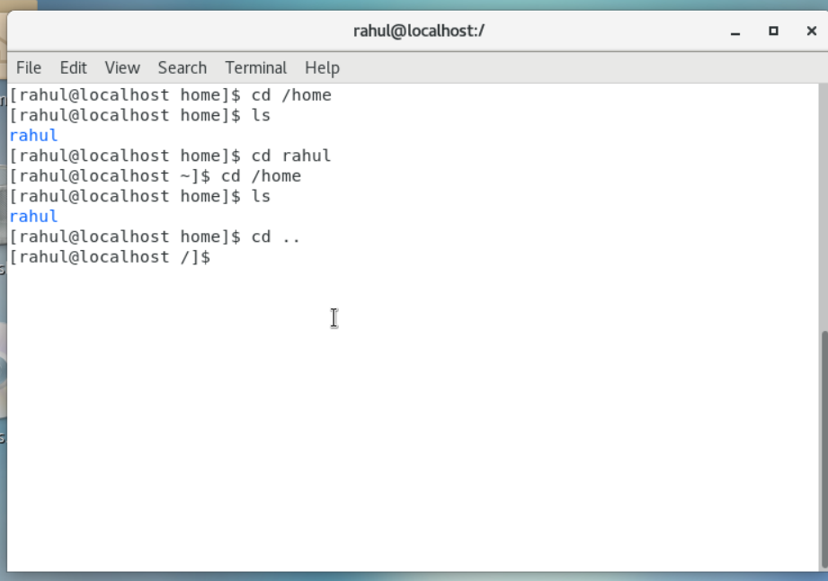

Cd .. will take us to the root directory again which is the parent directory

* Cd / var/www/html

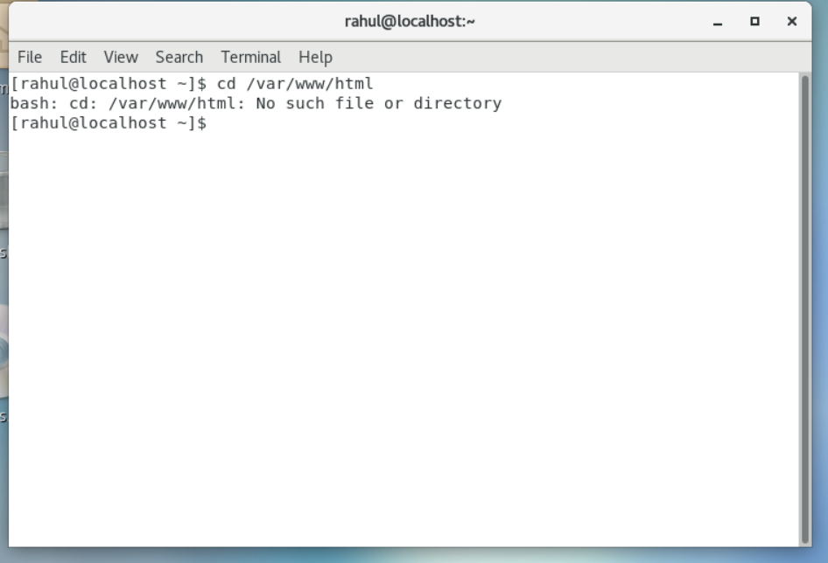

Throws the error that no such file or directory exists

*cd /root

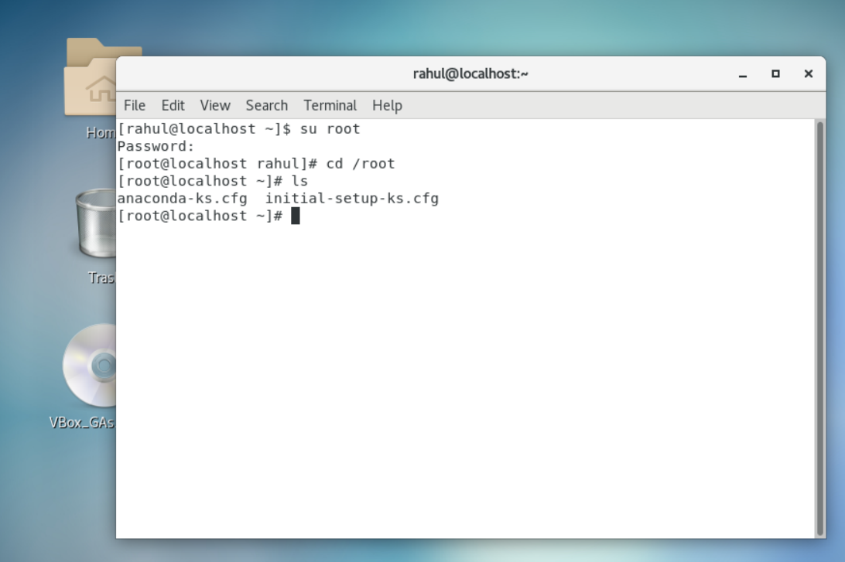

After hitting enter we can see the following files as mentioned in the above screenshot.

The Root directory is the home directory for the root user. Only the root user has its home directory at a different path

*cd /etc

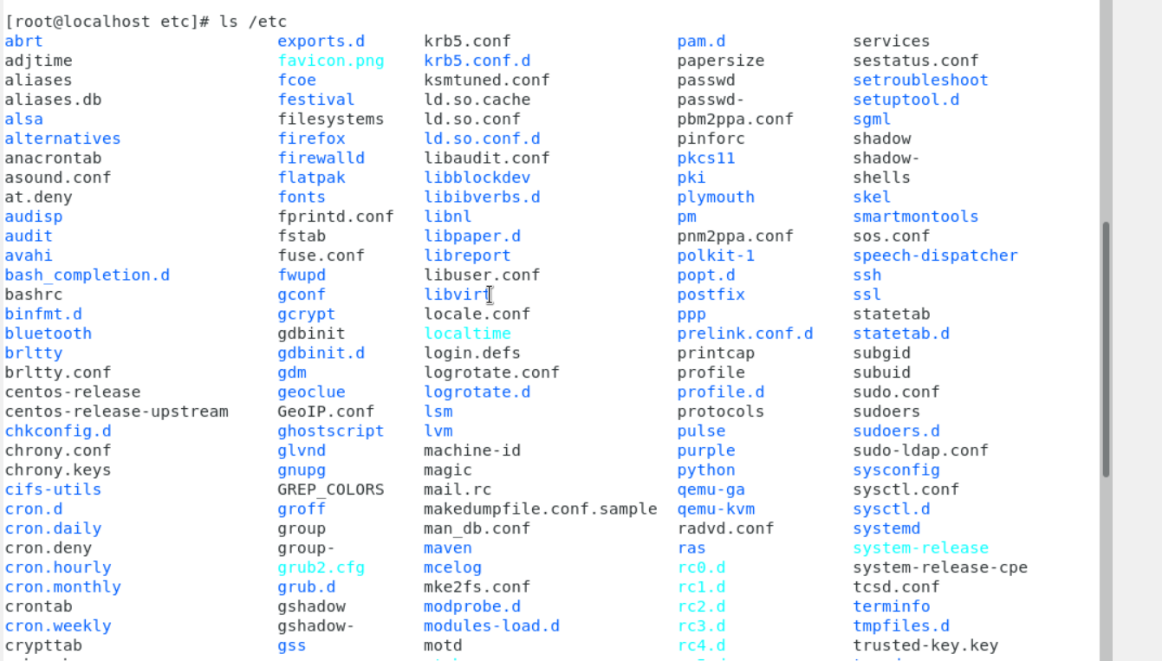

Etc is a directory in Linux that contains configuration files for the system. These files are used to store settings for the kernel, services, and applications

* Ls -al

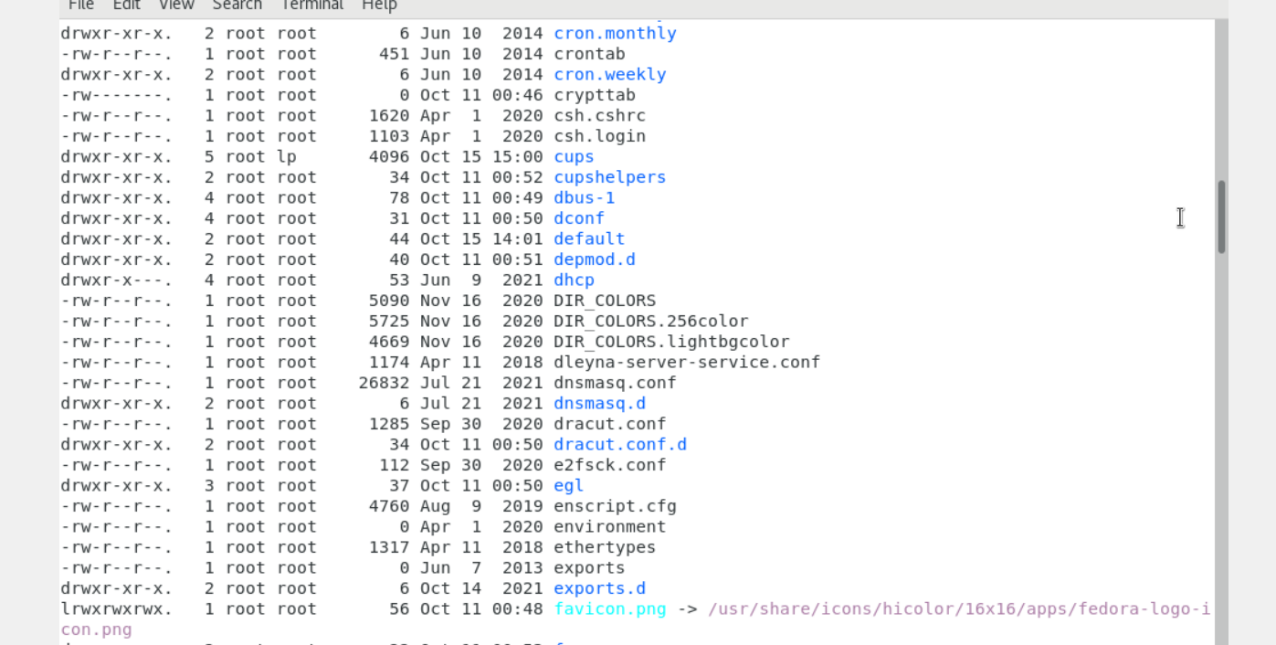

Ls – al also showed us some hidden files which were not previously visible.

* Ls -i

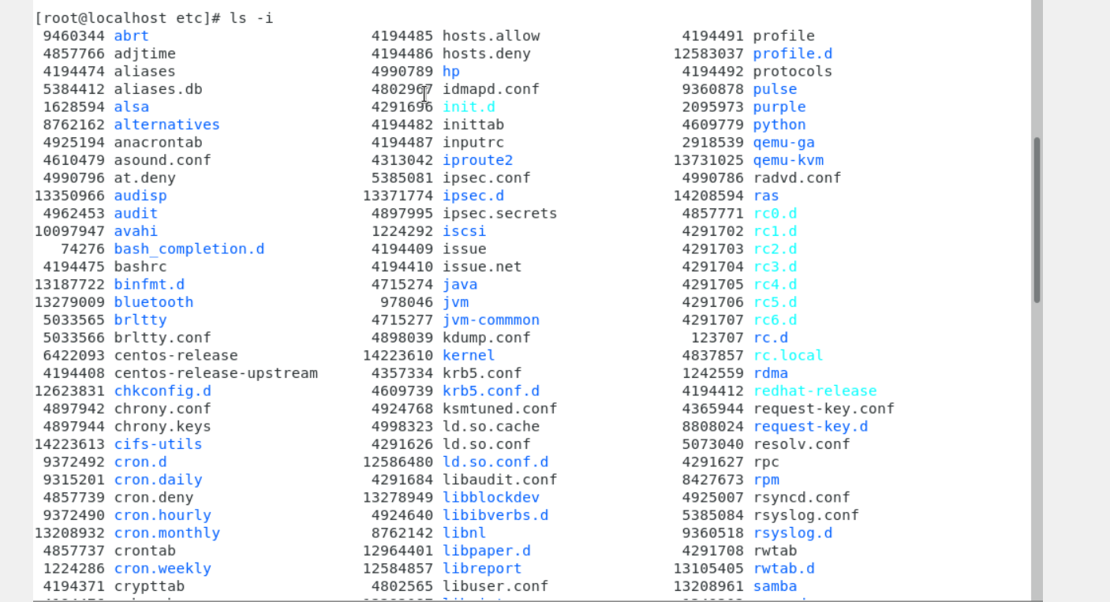

We get a unique index number of each file . Index number contains all the File info such as file size, owner info, permissions , filetype,etc.

Assignment 5

* Pwd

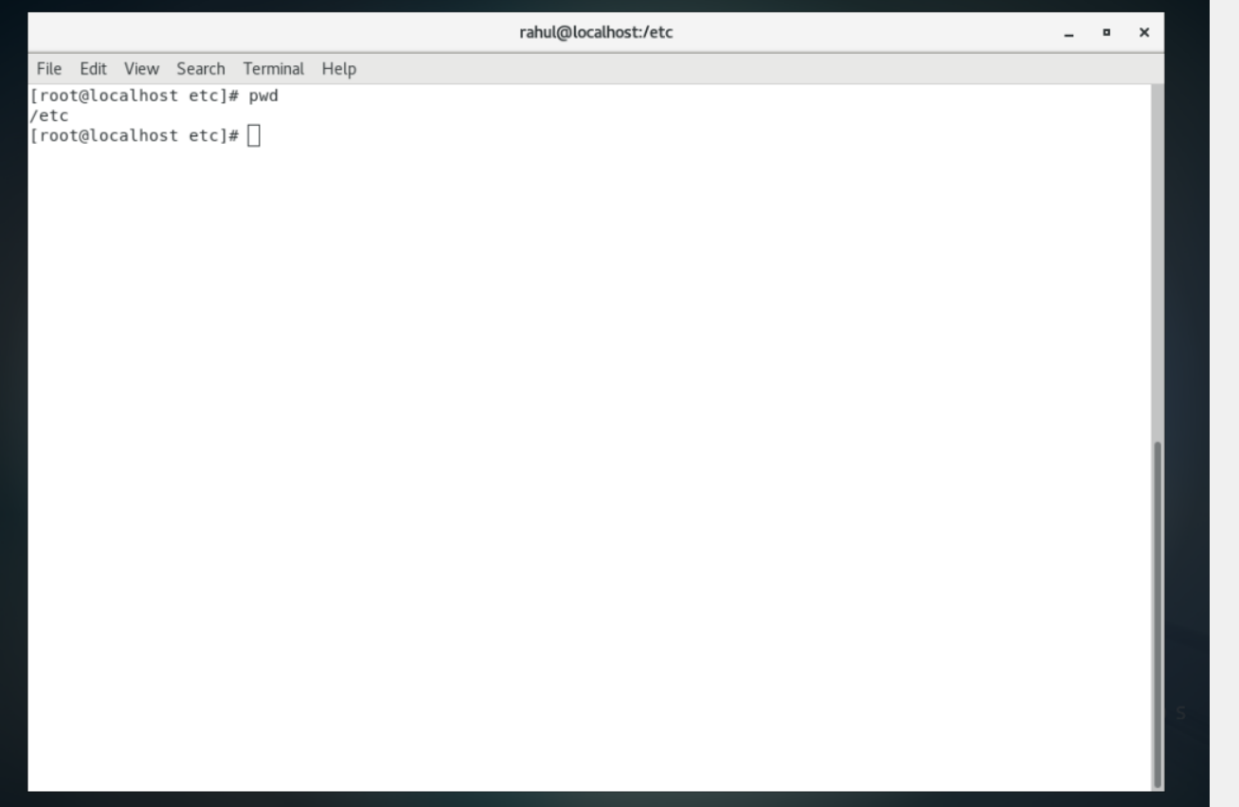

Pwd shows us the current directory in which we are working

* Cd /var

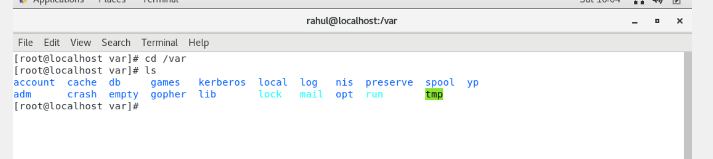

It gives the following output